Info Display App

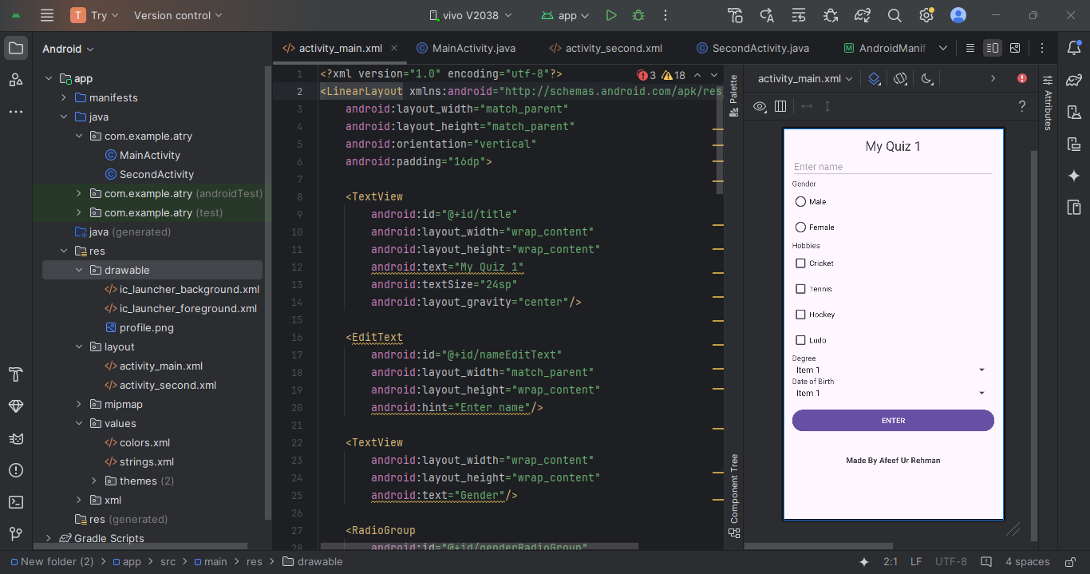

ActivityMain.XML
<?xml version="1.0" encoding="utf-8"?>
<LinearLayout xmlns:android="http://schemas.android.com/apk/res/android"
android:layout_width="match_parent"
android:layout_height="match_parent"
android:orientation="vertical"
android:padding="16dp">
<TextView
android:id="@+id/title"
android:layout_width="wrap_content"
android:layout_height="wrap_content"
android:text="My Quiz 1"
android:textSize="24sp"
android:layout_gravity="center"/>
<EditText
android:id="@+id/nameEditText"
android:layout_width="match_parent"
android:layout_height="wrap_content"
android:hint="Enter name"/>
<TextView
android:layout_width="wrap_content"
android:layout_height="wrap_content"
android:text="Gender"/>
<RadioGroup
android:id="@+id/genderRadioGroup"
android:layout_width="wrap_content"
android:layout_height="wrap_content">
<RadioButton
android:id="@+id/maleRadioButton"
android:layout_width="wrap_content"
android:layout_height="wrap_content"
android:text="Male"/>
<RadioButton
android:id="@+id/femaleRadioButton"
android:layout_width="wrap_content"
android:layout_height="wrap_content"
android:text="Female"/>
</RadioGroup>
<TextView
android:layout_width="wrap_content"
android:layout_height="wrap_content"
android:text="Hobbies"/>
<CheckBox
android:id="@+id/hobbyCricket"
android:layout_width="wrap_content"
android:layout_height="wrap_content"
android:text="Cricket"/>
<CheckBox
android:id="@+id/hobbyTennis"
android:layout_width="wrap_content"
android:layout_height="wrap_content"
android:text="Tennis"/>
<CheckBox
android:id="@+id/hobbyHockey"
android:layout_width="wrap_content"
android:layout_height="wrap_content"
android:text="Hockey"/>
<CheckBox
android:id="@+id/hobbyLudo"
android:layout_width="wrap_content"
android:layout_height="wrap_content"
android:text="Ludo"/>
<TextView
android:layout_width="wrap_content"
android:layout_height="wrap_content"
android:text="Degree"/>
<Spinner
android:id="@+id/degreeSpinner"
android:layout_width="match_parent"
android:layout_height="wrap_content"/>
<TextView
android:layout_width="wrap_content"
android:layout_height="wrap_content"
android:text="Date of Birth"/>
<Spinner
android:id="@+id/dobSpinner"
android:layout_width="match_parent"
android:layout_height="wrap_content"/>
<Button
android:id="@+id/enterButton"
android:layout_width="match_parent"
android:layout_height="wrap_content"
android:text="ENTER"
android:layout_marginTop="16dp"/>
<TextView
android:id="@+id/textView"
android:layout_width="wrap_content"
android:layout_height="wrap_content"
android:text="Made By Afeef Ur Rehman"
android:textSize="15sp"
android:textStyle="bold"
android:layout_marginTop="40dp"
android:layout_margin="40dp"
android:layout_gravity="center"/>
</LinearLayout>

MainActivity.JAVA
package com.example.atry;
import android.content.Intent;
import android.os.Bundle;
import android.view.View;
import android.widget.ArrayAdapter;
import android.widget.Button;
import android.widget.CheckBox;
import android.widget.EditText;
import android.widget.RadioButton;
import android.widget.RadioGroup;
import android.widget.Spinner;
import androidx.appcompat.app.AppCompatActivity;
public class MainActivity extends AppCompatActivity {
private EditText nameEditText;
private RadioGroup genderRadioGroup;
private Spinner degreeSpinner, dobSpinner;
private Button enterButton;
private CheckBox hobbyCricket, hobbyTennis, hobbyHockey, hobbyLudo;
@Override
protected void onCreate(Bundle savedInstanceState) {
super.onCreate(savedInstanceState);
setContentView(R.layout.activity_main);
nameEditText = findViewById(R.id.nameEditText);
genderRadioGroup = findViewById(R.id.genderRadioGroup);
degreeSpinner = findViewById(R.id.degreeSpinner);
dobSpinner = findViewById(R.id.dobSpinner);
enterButton = findViewById(R.id.enterButton);
hobbyCricket = findViewById(R.id.hobbyCricket);
hobbyTennis = findViewById(R.id.hobbyTennis);
hobbyHockey = findViewById(R.id.hobbyHockey);
hobbyLudo = findViewById(R.id.hobbyLudo);
// Populate degree spinner
ArrayAdapter<CharSequence> degreeAdapter = ArrayAdapter.createFromResource(this,
R.array.degrees_array, android.R.layout.simple_spinner_item);
degreeAdapter.setDropDownViewResource(android.R.layout.simple_spinner_dropdown_item);
degreeSpinner.setAdapter(degreeAdapter);
// Populate DOB spinner (example: years)
ArrayAdapter<CharSequence> dobAdapter = ArrayAdapter.createFromResource(this,
R.array.dob_array, android.R.layout.simple_spinner_item);
dobAdapter.setDropDownViewResource(android.R.layout.simple_spinner_dropdown_item);
dobSpinner.setAdapter(dobAdapter);
enterButton.setOnClickListener(new View.OnClickListener() {
@Override
public void onClick(View v) {
String name = nameEditText.getText().toString();
String degree = degreeSpinner.getSelectedItem().toString();
String dob = dobSpinner.getSelectedItem().toString();
int age = calculateAge(dob); // Implement age calculation based on DOB selection
String gender = ((RadioButton) findViewById(genderRadioGroup.getCheckedRadioButtonId())).getText().toString();
// Collect hobbies
StringBuilder hobbies = new StringBuilder();
if (hobbyCricket.isChecked()) hobbies.append("Cricket, ");
if (hobbyTennis.isChecked()) hobbies.append("Tennis, ");
if (hobbyHockey.isChecked()) hobbies.append("Hockey, ");
if (hobbyLudo.isChecked()) hobbies.append("Ludo, ");
// Remove trailing comma and space
if (hobbies.length() > 0) {
hobbies.setLength(hobbies.length() - 2);
}
Intent intent = new Intent(MainActivity.this, SecondActivity.class);
intent.putExtra("name", name);
intent.putExtra("gender", gender);
intent.putExtra("degree", degree);
intent.putExtra("hobbies", hobbies.toString());
intent.putExtra("dob", dob);
intent.putExtra("age", age);
startActivity(intent);
}
});
}
private int calculateAge(String dob) {
// Implement age calculation logic based on the selected dob
int birthYear = Integer.parseInt(dob);
int currentYear = 2024; // Adjust this to get the current year dynamically
return currentYear - birthYear; // Simplified age calculation
}
}

SecondActivity.XML
<?xml version="1.0" encoding="utf-8"?>
<LinearLayout xmlns:android="http://schemas.android.com/apk/res/android"
xmlns:app="http://schemas.android.com/apk/res-auto"
android:layout_width="match_parent"
android:layout_height="match_parent"
android:orientation="vertical"
android:padding="16dp">
<TextView
android:id="@+id/infoTitleTextView"
android:layout_width="wrap_content"
android:layout_height="wrap_content"
android:text="Information"
android:textAllCaps="true"
android:textSize="30sp"
android:layout_gravity="center"
android:layout_marginBottom="40dp"/>
<!-- Add Hare the image code -->
<ImageView
android:id="@+id/imageView"
android:layout_width="222dp"
android:layout_height="231dp"
android:layout_gravity="center"
app:srcCompat="@drawable/profile" />
<TextView
android:id="@+id/nameTextView"
android:layout_width="wrap_content"
android:layout_height="wrap_content"
android:textAllCaps="true"
android:textSize="24sp"
android:text="Name: "
android:layout_gravity="center"/>
<TextView
android:id="@+id/genderTextView"
android:layout_width="wrap_content"
android:layout_height="wrap_content"
android:text="Gender: "
android:textSize="20sp"
android:layout_gravity="center"/>
<TextView
android:id="@+id/degreeTextView"
android:layout_width="wrap_content"
android:layout_height="wrap_content"
android:textSize="20sp"
android:text="Degree: "
android:layout_gravity="center"/>
<TextView
android:id="@+id/hobbiesTextView"
android:layout_width="wrap_content"
android:layout_height="wrap_content"
android:textSize="20sp"
android:text="Hobbies: "
android:layout_gravity="center"/>
<TextView
android:id="@+id/dobTextView"
android:layout_width="wrap_content"
android:layout_height="wrap_content"
android:textSize="20sp"
android:text="DOB: "
android:layout_gravity="center"/>
<TextView
android:id="@+id/ageTextView"
android:layout_width="wrap_content"
android:layout_height="wrap_content"
android:textSize="20sp"
android:text="Message: "
android:layout_gravity="center"/>
<TextView
android:id="@+id/textView"
android:layout_width="wrap_content"
android:layout_height="wrap_content"
android:text="Made By Afeef Ur Rehman"
android:textSize="15sp"
android:textStyle="bold"
android:layout_marginTop="40dp"
android:layout_margin="40dp"
android:layout_gravity="center"/>
</LinearLayout>

SecondActivity.JAVA
package com.example.atry;
import android.os.Bundle;
import android.widget.TextView;
import androidx.appcompat.app.AppCompatActivity;
public class SecondActivity extends AppCompatActivity {
@Override
protected void onCreate(Bundle savedInstanceState) {
super.onCreate(savedInstanceState);
setContentView(R.layout.activity_second);
TextView nameTextView = findViewById(R.id.nameTextView);
TextView genderTextView = findViewById(R.id.genderTextView);
TextView degreeTextView = findViewById(R.id.degreeTextView);
TextView hobbiesTextView = findViewById(R.id.hobbiesTextView);
TextView dobTextView = findViewById(R.id.dobTextView);
TextView ageTextView = findViewById(R.id.ageTextView);
String name = getIntent().getStringExtra("name");
String gender = getIntent().getStringExtra("gender");
String degree = getIntent().getStringExtra("degree");
String hobbies = getIntent().getStringExtra("hobbies");
String dob = getIntent().getStringExtra("dob");
int age = getIntent().getIntExtra("age", 0);
nameTextView.setText("Name: " + name);
genderTextView.setText("Gender: " + gender);
degreeTextView.setText("Degree: " + degree);
hobbiesTextView.setText("Hobbies:" + hobbies);
dobTextView.setText("DOB: " + dob);
ageTextView.setText("Message:" + (age < 18 ? "You are under 18" : "you are 18 or older"));
}
}

ActivityManifest.XML
<?xml version="1.0" encoding="utf-8"?>
<manifest xmlns:android="http://schemas.android.com/apk/res/android"
xmlns:tools="http://schemas.android.com/tools">
<application
android:allowBackup="true"
android:dataExtractionRules="@xml/data_extraction_rules"
android:fullBackupContent="@xml/backup_rules"
android:icon="@mipmap/ic_launcher"
android:label="info"
android:roundIcon="@mipmap/ic_launcher_round"
android:supportsRtl="true"
android:theme="@style/Theme.Try"
tools:targetApi="31">
<activity
android:name=".SecondActivity"
android:exported="false" />
<activity
android:name=".MainActivity"
android:exported="true">
<intent-filter>
<action android:name="android.intent.action.MAIN" />
<category android:name="android.intent.category.LAUNCHER" />
</intent-filter>
</activity>
</application>
</manifest>

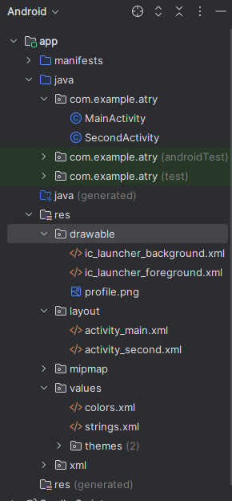
Strings.XML
<resources>
<string name="app_name">My Quiz</string>
<string-array name="degrees_array">
<item>Bachelor</item>
<item>Diploma</item>
<item>Master</item>
<item>PhD</item>
</string-array>
<string-array name="dob_array">
<item>2005</item>
<item>2006</item>
<item>2007</item>
<item>2008</item>
<item>2009</item>
<item>2010</item>
<item>2011</item>
</string-array>
</resources>

